**PARL AI Image Description Max version**

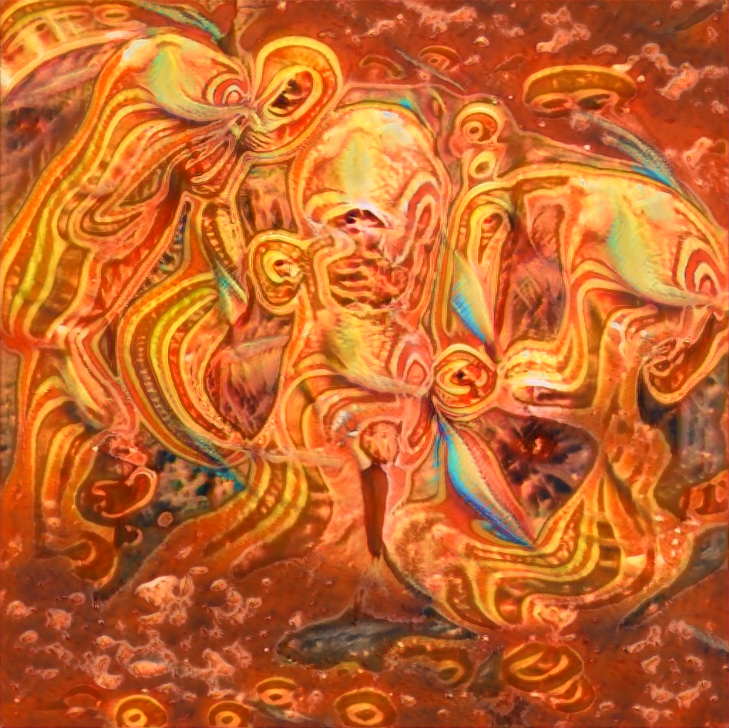

* i wonder takes to learn to draw like . do know who the artist is ?
* i could make some instruments out of these and get some friends together to make a band . we 'd call the golden chandelier band . anyone can join -- as long as do n't mind being covered head-to-toe with golden spray paint every weekend for our concerts and gigs .
* if only i could 've been at the drawing of these pictures . i just wonder when through the minds of the people who created eccentric art .
* every piece must be perfectly arranged .
* to view all the items must watch closely
* i forgot those symbols mean .
* i would love an abstract painting of perhaps by picasso .
* these decorations would look fabulous in my town house study .
* these stained glass pieces were made by elves .
* i doubt is considered good art .
* i wonder if i woudl use to make counterfeit goods .
* i would spend any amount of money to have piece in my house !

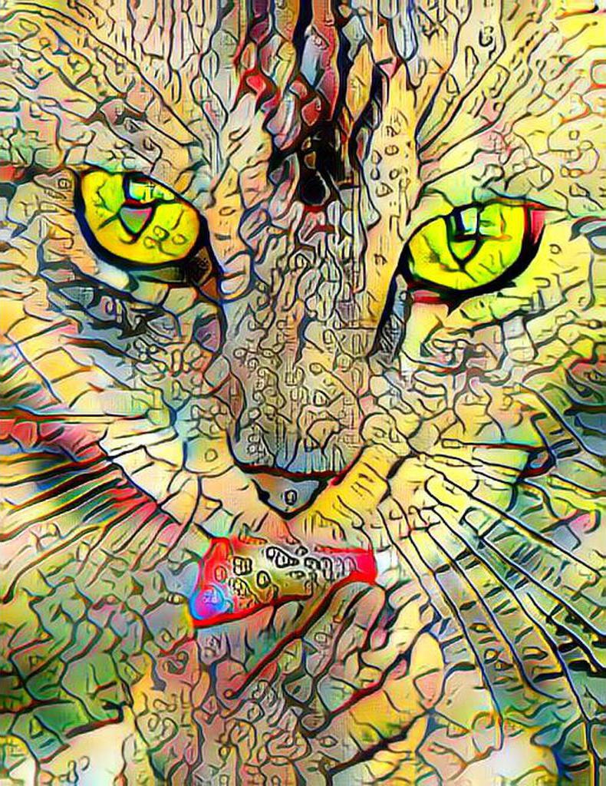

* i wonder kind of plant is let me look up .
* i hear those flowers are poisonous to one out of every two people , i 'd love to test out myself .
* i wonder if these flowers are sentient like animals and humans are .
* i would sort the numbers in descending order , making easier to read .
* there are actually 5 types of flowers in photo
* i forgot flowers could be so yellow
* i would like to have a painting of
* these decorations would look fabulous in my town house study .
* flowers have deep , magical powers .
* i am not sure if plant is real
* i wonder how easy would be to steal statue .
* these flowers look very expensive .

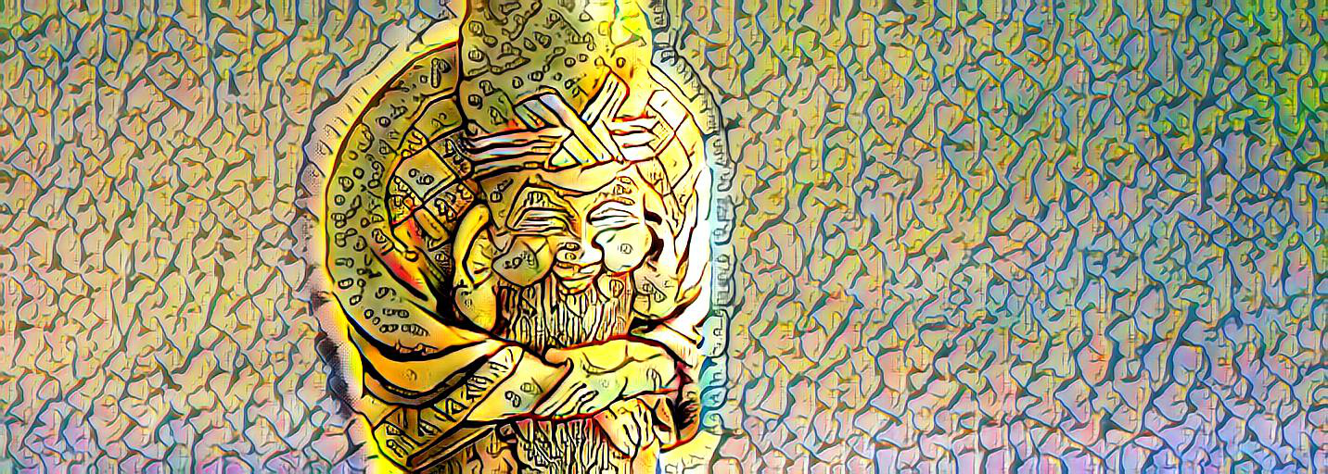

* i wonder takes to learn to draw like . do know who the artist is ?
* i am going to try these skewers and then go and share with hungry of the world
* steampunk awakens my philosophical side , so many what-ifs in our past as humans .
* seem to have put a lot of work into the costume . there is a lot of detail in the arms and hat .
* really notice the way the petals of the cactus are arranged up close .
* i forgot which artist made these .
* a gorgeous photograph . the lighting almost makes look like a watercolor painting .
* these decorations would look fabulous in my town house study .
* i wonder if know are a walking mystical symbol . the center is a specific alchemical symbol ..
* i am skeptical santa claus is real
* i wonder how easy would be to steal statue .
* i would spend any amount of money to have piece in my house !

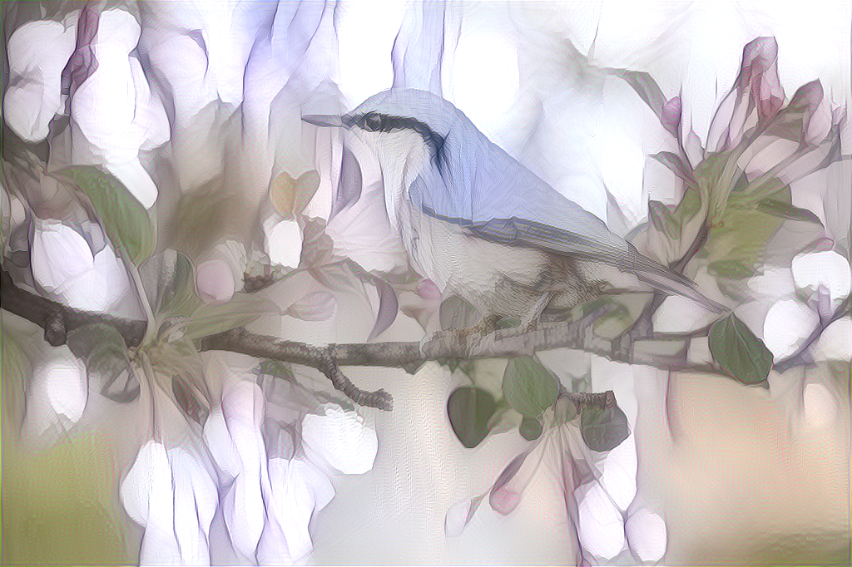

* wonder where is ? never seen birds liek
* i would love to try to catch a bird on a bird feeder with my bare hands .
* labels , who needs ? break free and set own course . unless 're a product . then kinda need 'em .
* the artwork on those banners is very detailed and probably took a good amount of time .
* the artwork on those banners is very detailed and probably took a good amount of time .
* i forgot why i came here .
* i would like to have a painting of
* these decorations would look fabulous in my town house study .
* there is mystical energy in place .
* im not sure people in the image are real , or at least in its mayority .
* i wonder how easy would be to steal statue .
* i just bought my 23rd zebra painting !

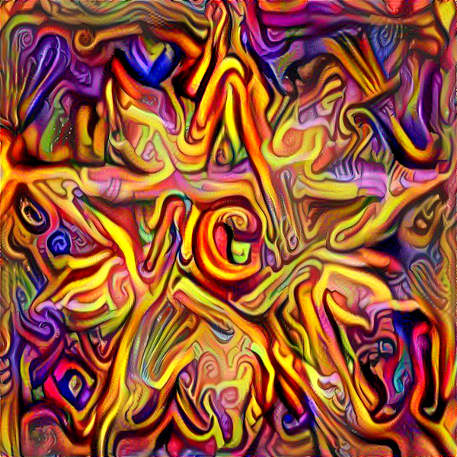

* i wonder kind of plant is let me look up .
* i hear those flowers are poisonous to one out of every two people , i 'd love to test out myself .
* i love the diverse color scheme of of the flowers at different parts of the park .
* some of the ribbons are longer than others and 's a little uneven
* there are actually 5 types of flowers in photo
* i forgot flowers could be so yellow
* love how these colors merge together like a piece of art .
* the decorations are so glamorous . included every color .
* flowers have deep , magical powers .
* i am not sure if plant is real
* looks like someone is looking for public flowers to steal .
* those grapes look absolutely marvelous , could make a great wine to add to my collection .